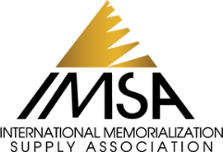 Speakers Bureau Biography

[INSERT SPEAKER PHOTO HERE]
Name: Click here to enter text.
Company/Firm Name: Click here to enter text.
Primary Phone: Click here to enter text.
Email Address: Click here to enter text.
Social Media: Click here to enter text.

Speaking Topics (please list actual presentation titles)

Areas of Expertise (Ex: Cremation, Business Strategy, Operations, Hiring & Talent Development)

Speaker Biography (limited to 750 characters)

Do Your Speaking Engagements Include Certified Continuing Education Credits?
- Yes – please list topics/states:
- No
Speaker Fees*
- Speaker requires only conference registration to be paid/reimbursed
- Speaker requires conference registration plus travel costs to be paid/reimbursed
- Other fees to be discussed directly between speaker and conference organizer
*Speaker fees are determined by the individual speakers and will be negotiated directly with the conference organizer. IMSA does not participate in nor does it profit from speaker fees.
This speaker is willing to travel:
- Anywhere in the U.S.
- Only to these locations:
- Internationally (please list):
Speakers commit to responding to requests within 3 business days.

